Appendix I: Specific Sampling Protocols and Procedures for Conducting Adult chinook salmon and steelhead Redd SurveyS

Yuba River Chinook Salmon and Steelhead Redd Surveys

Background

Redd counts have been used widely to estimate or provide indices of adult salmonid escapement or abundance, and examine the spatial and temporal distribution of spawning adult salmonids. Redd counts are the primary metric used for monitoring salmonids in Washington and Oregon (Boydstun and McDonald 2005, as cited in Gallagher et al. 2007). Since the 1950s, redd counts have been used in Idaho for relative abundance estimates and examining trends in abundance (Elms-Cockrun 1999, as cited in Kucera and Orme 2007). Chinook salmon redds varied spatially and temporally over a large wilderness basin in Idaho from 1995-2003 (Isaack and Thurow 2006).

Redd superimposition occurs when later arriving female salmonids dig redds on top of existing redds. Redd superimposition can occur when spawning gravel is limited and can cause substantial mortality to eggs deposited on a redd before redd superimposition occurred (Hayes 1987; McNeil 1964). Spawning gravel availability has been found to be an important factor limiting Chinook salmon populations in streams where dams capture sediments and reduce supply of gravel to downstream reaches (EA Engineering Science and Technology 1992).

Redd surveys will be used in the lower Yuba River to monitor Chinook salmon and steelhead redd attributes, redd superimposition, abundance, and spatial and temporal spawning distribution. Redd surveys will be conducted throughout the spawning periods of spring-run, fall-run, and late fall-run Chinook salmon and steelhead using two types of ground based redd surveys – extensive area single pass redd surveys and index area redd surveys. Data collected during the extensive area single pass surveys will be used to monitor abundance and spatial and temporal spawning distribution of steelhead and Chinook salmon. Index area redd surveys will be used to collect redd attribute data and redd superimposition data. Results from the index area survey will be used to improve data analysis of the surveys. For example, the average area of Chinook salmon redds will be used to estimate the number of redds in the measured area of superimposition.

Goals of the redd surveys include: (1) evaluate and compare the spatial and temporal distribution of redds and redd superimposition over the spawning periods for Chinook salmon and steelhead spawning in the lower Yuba River, (2) compare the magnitude of lower Yuba River flows and water temperatures with the annual and seasonal numbers of redds, redd superimposition, and timing of spawning for Chinook salmon and steelhead, (3) estimate adult fall-run Chinook salmon and steelhead abundance in conjunction with angler survey and Vaki Riverwatcher data, and (4) establish a long term data set that can be used to evaluate habitat usage and substrate preferences of Chinook salmon and steelhead on the lower Yuba River under differing biotic and abiotic conditions.

- Survey Location

The lower Yuba River extends about 38.6 km from Englebright Dam, the first impassible fish barrier on the river, downstream to the confluence with the Feather River near Marysville, California. Approximately 32.2 km of the 38.6 km of habitat will be surveyed during the extensive area kayaking redd surveys. Two miles of the lower Yuba River immediately below Englebright Dam to the Narrows Pool will not be surveyed due to rugged and dangerous conditions in the steep canyon known as the Narrows. Habitat usage in this reach for spring-run Chinook salmon will be evaluated using acoustic tagging surveys (see Appendix D – Specific sampling protocols and procedures for acoustic tagging surveys). Additionally an approximate 3.2 km reach of the lower Yuba River from Simpson Lane Bridge to the confluence with the Feather River will not be surveyed because this reach is considered a migration corridor and is not typically utilized for spawning. This section will be surveyed once during peak spawning to ensure the area is in fact not being utilized.

Surveys reaches for the extensive area survey include:

      - Reach 1 – Narrows pool (approximately 3.2 kilometers down river from Englebright Dam) to the State Route 20 Bridge.
      - Reach 2 – State Route 20 Bridge to Daguerre Point Dam.
      - Reach 3 – Daguerre Point Dam to Simpson Lane Bridge (approximately 3.2 kilometers upstream from confluence of Feather River).
Reaches will be subdivided if needed during periods of heavy spawning.

Two 100 meters long study sites will be used for the index area redd surveys. The locations were chosen based on four criteria; general location on river (i.e., above and below Daguerre Point Dam (DPD)), accessibility, likelihood of spawning activity, and feasibility of data collection based on local abiotic conditions. The upper study site is located just down stream of the Narrows pool. The lower study site is located just downstream of DPD. Annually, the River Management Team (RMT) Planning Group will review data and determine whether these two sites should continue to be used or moved.

High resolution mapping conducted on the lower Yuba River will be used to help identify potential deep water spawning habitat (see Appendix B – Specific sampling protocols and procedures for delineating morphological units and mesohabitats).

- Survey Period

With implementation of the Yuba Accord, the adult Chinook salmon and steelhead redd surveys will be considered a long-term monitoring effort. Following the pilot year (2008/2009), redd surveys are anticipated to be conducted annually for at least five more years, from 2009/2010 through 2013/2014. The RMT Planning Group will review the data and reports on an annual basis, and determine whether the overall duration of the redd survey should be adjusted.

Redd surveys will begin prior to the spawning season in mid-August and extend through late-April. Generalized spawning periods by species and run in the lower Yuba River are listed below and represent a predicted range for spawning. To encompass all salmonid spawning periods, surveys will begin at the onset of spring-run Chinook salmon spawning and extend through the end of the steelhead spawning season.

- Spring-run Chinook Salmon – late-August to mid-October
- Fall-run Chinook Salmon – early-October to mid-January
- Late fall-run Chinook Salmon – early-January to late-April
- Steelhead trout – early-January to late-April

- Sampling Frequency

Extensive area surveys will be completed monthly beginning in October. Extensive area surveys will be set for the first full week of each month (depending on weather conditions, personnel needs, etc) to catch the peak spawning of each run. The estimated time to complete one survey is 3-5 days based on floating downstream in a kayak, however the time could be extended due to an increase in the number of redds encountered during the survey.

Index area surveys of the two study sites will be completed every 2-3 days. Later in the spawning season, survey frequency may decrease to weekly or bi-monthly due to a reduced number of newly identified redds.

Due to safety concerns, deep water spawning habitats will be surveyed twice a season during peak spawning. Peak spawning will be based on the index and extensive area survey data.

- Sample Size

The sample size for the redd surveys is the number of redd surveys conducted for each survey type (i.e., extensive area redd survey, index area redd survey, and deep water survey).

The sample size for collecting data on redd attributes and superimposition during the index area redd survey is the number of redds examined.

The sample size for collecting data on redds during the extensive area redd survey and deep water survey is the number of redds examined.

- Survey Protocols and Procedures

  - Preseason Planning – Lead Biologist Responsibilities and Coordination Activities

At least one month in advance of the Chinook salmon spawning period, preseason planning activities for the redd surveys will be initiated by the lead biologist. Preseason preparations include: (1) developing the annual survey schedule, (2) obtaining all necessary equipment, (3) and training all survey personnel.

Several weeks prior to the onset of sampling, a planning meeting will be held with the RMT Planning Group to review the survey procedures and logistics. The purpose of this meeting is two-fold: (1) to verify that all necessary preparations and planning arrangements have been completed for that year’s redd surveys, and (2) to provide an opportunity to make adjustments to the survey timing, logistics or approach if new information becomes available or if deemed necessary by the RMT Planning Group.

  - Data Collection and Sampling Techniques

The observation of redds and species redd identification is affected by the visibility of the stream substrate. Substrate visibility can be reduced by turbidity, surface disturbance, and other conditions including wind, fog, high flows, and angle of the sun. Visibility will be improved by surveyors wearing polarized sunglasses. Weather and water turbidity will be monitored to improve the survey. Surveys will only be conducted when weather conditions are suitable and when water turbidity is below 10 NTU (Nephelometric Turbidity Units). During optimal weather conditions, visibility of the substrate will be clear at a depth of 3 m and a turbidity level of 0.91 NTU (unpublished data - 2008/2009 pilot study).

    - Redd species identification

A size criteria will be used for redd species identification of steelhead and Chinook salmon redds. A redd that is less than 1.56 m long and less than 1.37 m wide will be considered a steelhead redd. Redds larger than this length and width will be considered a Chinook salmon redd. These criteria were used to classify 129 Chinook salmon redds with 96% accuracy and 28 steelhead redds with 53% accuracy in the Yuba River (USFWS 2008). Any uncertainty with redd species identification using this size criteria will be addressed by examining the timing of spawning, gravel size, and the location of the redd in the river channel. Steelhead tend to use smaller gravel and spawn in shallower water than do Chinook salmon. Surveyors must be in consensus for redd species identification.

Error in redd species identification will be reduced by comparing the physical dimensions and locations for all known redds (i.e., redds which were positively identified with one species or another building or guarding them). During the index area redd survey, surveyors will measure the dimensions of all newly constructed redds, record the presence of a species building or guarding them, and record the location of the redd using a GPS.

Differentiating between steelhead, Sacramento sucker (Catostomus occidentallis) and Pacific lamprey (Lampetra tridentata) redds is of concern because these three species clean the gravel during spawning. Suckers do not typically spawn until late-March and April, and are generally very visible during their spawning period. Steelhead redds are generally easy to distinguish, because they create a noticeable pit and tail spill in the gravel during redd construction. DeHaven (2002, as cited by DWR 2002) often found it difficult to distinguish Pacific lamprey redds from steelhead redds. The Oregon Department of Fish and Wildlife (1999) distinguish lamprey redds and steelhead redds using redd dimension measurements. A steelhead redd has a longer length than width and the tailings are evenly distributed downstream by the current (Figure 1). Lamprey redds generally have a neat and round appearance, with a conical bowl (Figure 2). The unique characteristic of a lamprey redd, is the placement of the tailings upstream from the redd (Figure 3). Lamprey excavate their redds by sucking onto the gravel and then depositing it outside the redd. Figure 4 shows a lamprey redd with tailings from the redd placed perpendicular to the flow. Based on the 2008/2009 pilot redd survey in the Yuba River, lamprey were observed spawning in late-March and early-April. Lampreys were found spawning in the most downstream sampling reach of the lower Yuba River where sand was the subdominant substrate.

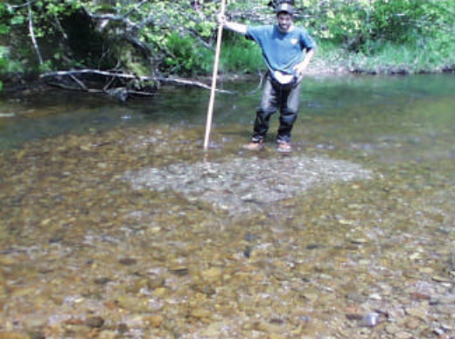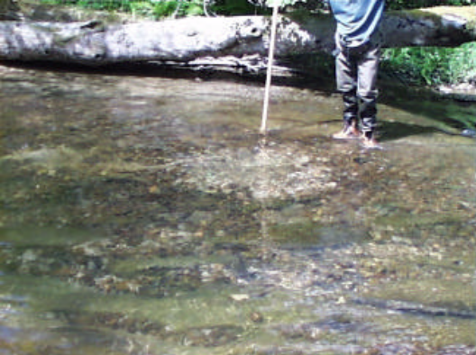

Figure 1. Steelhead redd (ODFW 1999). Figure 2. Lamprey redd (ODFW 1999).

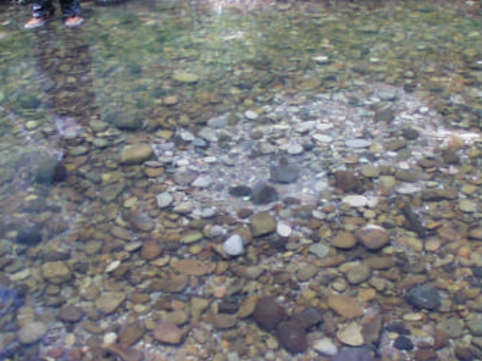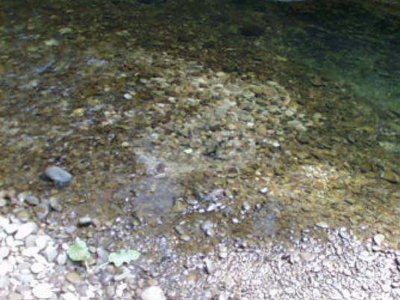
Figure 3. Lamprey redd, note placement Figure 4. Lamprey redd showing placement
of excavated rocks upstream and excavated debris to the side of the redd
perpendicular to flow (ODFW 1999). (ODFW 1999).
    - Ground based extensive area single pass redd surveys

The extensive area single pass redd surveys will be conducted using a kayak and a survey crew of two people. Each surveyor will survey one side of the river working downstream. Side channels in the survey area may require walking.

Prior to conducting a survey, the following data will be recorded: (1) surveyors’ initials, (2) survey section, (3) weather, (4) stream flow (cfs), and (5) turbidity (NTU) on the data sheet (Attachment 1). Turbidity will be measured using a portable turbidity meter, Hach Model 2100P, and a representative sample of water collected at the top of the survey section. Flow data will be obtained from the Yuba River Smartsville and Marysville gauge through the California Department of Water Resources’ (CDWR) online California Data Exchange Center (CDEC). The Smartsville gauge will be used for flows above DPD and the Marysville gauge for flows below DPD.

During the survey for each redd observed, the following data will be recorded (Attachment 1): (1) a GPS (Trimble GeoExplorer XT) location with a unique identifying number (i.e., Date + plus redd number; e.g. 082908-001), (2) total dimensional area (using a GPS) for areas appearing to contain multiple redds with no clear boundaries (i.e., possible redd superimposition), (3) habitat type (i.e., pool, riffle, run, or glide), (4) substrate composition based on size (Table 1), (5) number of fish observed on the redd, (6) redd species identification, (7) location information (i.e., side channel or main channel), (8) potential of redd superimposition (i.e. does the redd appear to have been constructed on the top of neighboring redds), and (9) any other comments. The path each surveyor surveyed down the river will be recorded using the Garmin GPSMAP 60Cx GPS units to ensure all sections of the river are surveyed. Flow conditions specific to each redd will be assessed using high resolution mapping (see Appendix B – Specific sampling protocols and procedures for delineating morphological units and mesohabitats).

Table 1. Substrate type and size with associated classification number for describing substrate composition of each redd in the lower Yuba River.
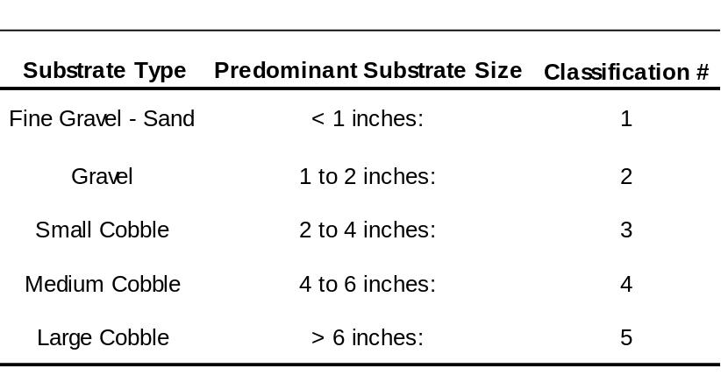

    - Index area redd surveys

The index area survey will be conducted by a survey crew of two people. For each study site, the 100 meter reach will be flagged at every 10 meters on both sides of the river. Each entire 10 meter section will be surveyed by snorkeling from river right to river left and from an upstream to down stream direction.

Prior to conducting the survey, the following data will be recorded on the data sheet (Attachment 2): (1) surveyors’ initials, (2) survey section, (3) weather, (4) stream flow (cfs), and (5) turbidity (NTU). Turbidity will be measured using a portable turbidity meter, Hach, Model 2100P, and a representative sample of water collected at the top of the survey section. Flow data will be obtained from the Yuba River Smartsville and Marysville gauge through the California Department of Water Resources’ (CDWR) online California Data Exchange Center (CDEC). The Smartsville gauge will be used for flows above Daguerre Point Dam (DPD) and the Marysville gauge for flows below DPD.

During the redd survey, surveyors will collect data for each redd observed. All observed redds will be counted, and the area or outline of the redd and location of each redd will be recorded using a GPS unit (Trimble GeoExplorer XT) with sub-foot accuracy. In addition, physical dimensions of each redd will be measured and recorded on a data sheet in the event that satellite reception is poor. To prevent individual redds from being double counted, redds in shallower areas will be marked using a stake with a unique number and deep redds will be marked with an orange painted rock. For each survey, newly constructed redds encountered will be given a unique identifying number (i.e., Date + plus red number; e.g. 082908-001) in the GPS. The surveyors will collect the and record the following data for each redd (Attachment 2): (1) dimension measurements according to Figures 5 and 6 and Table 2, and measurement of the depth at the head and center of the redd (cm), (2) dominant/subdominant substrate composition (Table 1), (3) physical location in river (i.e., side channel or main channel), (4) potential for superimposition (i.e. does the redd appear to have been constructed on top of the neighboring redds), (5) number of fish present on redd, (6) redd appearance (e.g., presence of a clear pot, intense scouring of gravel, absence of silt and algae covering the redd site), and (7) any other comments. All data will be recorded on the data sheet (Figure 6). The individual redd measurements will be compared to the GPS measurements to cross-reference calculations for (1) redd area, (2) the percentage of redd superimposition between two or more redds, and (3) the average redd size. Redd area will be calculated using the standard equation for the area of an ellipse, and the dimension measurements recorded. Depth measurements will be used to calculate the range and average depth for redds for each species and run observed in the index area.

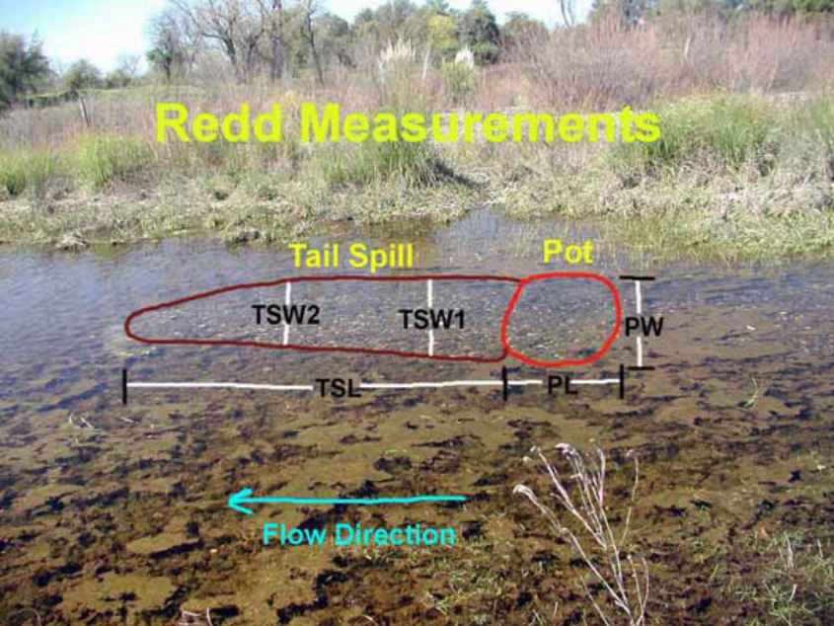

Figure 5. Illustration of steelhead redd measurements (PL = pot length; PW = pot width; TSL = tail-spill length; TSW2 and TSW1 = tail-spill widths,), as presented in Hannon and Deason (2005a).

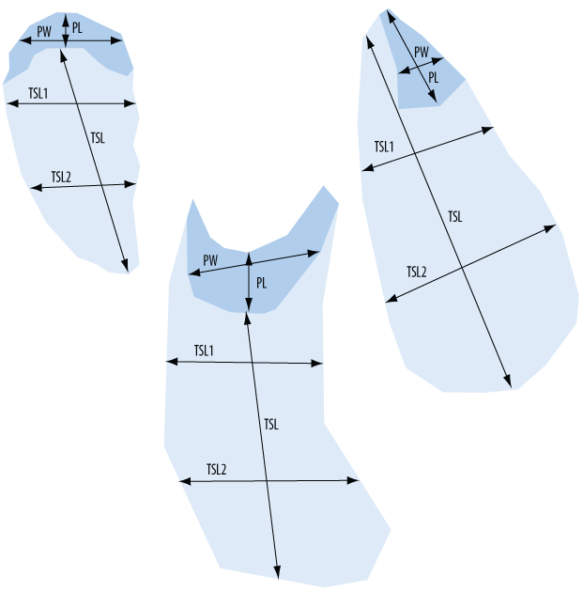

Figure 6. Measurements for unusually shaped redds (PL = pot length, PW = pot width, TSL = tail-spill length, TSL1 and TSL2 = tail-spill widths). Illustration reproduced from Gallagher et al. 2007.

Table 2. Description of redd dimension measurements displayed on Figures 5 and 6.

Pot Length (PL) | Total length of the pot parallel to the stream flow, and should be measured in meters (to the nearest cm) from the top to bottom edge. When the pot is irregularly shaped, estimate the total length as accurately as possible.
Pot Width (PW) | Maximum width of the pot perpendicular to the stream flow or pot length in meters (to the nearest cm). When the pot is irregularly shaped, estimate the total length as accurately as possible.
Tail Spill Length (TSL) | Total length of the tail spill parallel to the stream flow (in meters to the nearest cm). Measurements will be taken from the top edge (i.e., downstream edge of the pot) to bottom edge of the tail spill.
Tail Spill Width 1 (TSW1) | Maximum width of the tail spill perpendicular to the stream flow or pot length (in meters to the nearest cm). Measurements will be taken from one edge to the other, about one-third of the distance downstream from the top edge of the tail spill
Tail Spill Width 2 (TSW2) | Maximum width of the tail spill perpendicular to the stream flow or pot length (in meters to the nearest cm). Measurements will be taken from one edge to the other, about two-thirds of the distance downstream from the top edge of the tail spill.

    - Subsampling Procedures for Investigating Deep Water Spawning Habitat

The USFWS (2008) found that steelhead spawning in the lower Yuba River occurred at depths ranging from 0.4 to 19.9 feet deep. USFWS (2008) established ten study sites in the lower Yuba River, and the location of most redds (both in shallow and deep water) were recorded with a GPS unit, to ensure that redds were not measured twice. The USFWS (2008) do not specify the reach or reaches where deep water steelhead redds were observed. Although combined habitat suitability and redd locations are presented in Appendix L of the USFWS (2008) report, the steelhead redds corresponding to the combined habitat suitability score associated with deep water spawning (e.g., 19.9 feet) could not be identified.

High resolution mapping conducted on the lower Yuba River will be used to help identify potential deep water spawning habitat (see Appendix B – Specific sampling protocols and procedures for delineating morphological units and mesohabitats). Each survey season in November and March, to further investigate the potential for deep water spawning, surveyors will visually inspect identified potential deep water habitat via snorkeling and noting presence or absence of redds.

  - Field Gear Decontamination

New Zealand mudsnails (Potamopyrgus antipodarum, NZMS) were first discovered in California (Owens River) in 1999. The NZMS has the ability to adapt to new ecosystems and alter food web dynamics. Controlling the spread of the NZMS is a top priority for the California Department of Fish and Game. CDFG needs to ensure that their employees are not spreading NZMS in the course of carrying out their duties. Therefore, a field gear decontamination protocol for NZMS has been developed and will be used for gear used in the lower Yuba River.

The following procedures for decontaminating field gear (i.e., waders, wading boots, boot insoles, nets, wading sticks, or anything else that comes into contact with the water) developed by CDFG (2008) will be followed prior to entering a new body of water or at the end of the day, whichever occurs first. Freezing field gear will be the first option if a freezer is available. Freezing has no adverse effect on field gear or on the environment, and is the most cost effective means of decontamination.

    - Freezing Procedure

- Place field gear into a new large plastic bag and seal before placing into the vehicle. Any surface that comes in contact with field gear can become contaminated.

- Upon returning to a CDFG office, place the plastic bag containing the field gear into a freezer (<0 °C) for a minimum of six hours.

    - Immersion Procedure

- If field gear is not going to be decontaminated on site, place the field gear into a new large plastic bag and seal before placing into the vehicle.

- Place all field gear that came in contact with water into a container of sufficient size to allow gear to be completely immersed in decontamination solution.

- Pour decontamination solution (5% Sparquat) into container to allow complete immersion of all field gear. If necessary, weigh down the gear to ensure the gear is completely immersed. To make the decontamination solution, use a ratio of 7 oz of Sparquat to 1 gallon of water.

- Soak field gear in decontamination solution for a minimum of 15 minutes.

- Remove field gear from the decontamination solution and inspect gear to ensure that all debris that could contain NZMS has been removed. Use a stiff brush to remove any debris that remains on the field gear.

- Rinse field gear with fresh water. Do not use water from the sampling site. Using water from the sampling site will contaminate your field gear. Rinse water should not be allowed to enter a storm drain or water body.

- Decontamination solution must be disposed of into a sanitary fill for proper waste treatment. Decontamination solution cannot be dumped on the ground under any circumstances. Decontamination solution cannot be disposed into a septic system. Five- gallon disposal containers will be provided to personnel for use in disposing decontamination solution. Decontamination solution can be disposed of at the CDFG Regional office.

    - Spray Bottle Procedure

- Create a decontamination solution that contains 10% Sparquat (900ml of water and 100ml of Sparquat).

- Liberally spray field gear until gear is completely saturated. Ensure that hard to reach areas are sprayed thoroughly.

- Allow decontamination solution to remain on field gear for a minimum of 15 minutes.

- Rinse sampling gear with fresh water. Do not use water from the sampling site. Using water from the sampling site will contaminate the field gear.

- Rinse water should not be allowed to enter a storm drain or water body.

The spray bottle procedure should not be used except under very extreme circumstances when freezing or immersion procedures cannot be completed. Contact time and concentration of decontamination solution from spray bottle procedures cannot be guaranteed, which does not ensure 100% mortality of NZMS.

  - Watercraft Decontamination

California’s waterways currently face the challenge of invasion by quagga mussels (Dreissena bugensis) and zebra mussels (Dreissena polymorpha). Zebra mussels, a species native to Eastern Europe, were first introduced in the United States through ballast water released into the Great Lakes in the late 1980s. Quagga mussels soon followed.

In January 2007, quagga mussels were discovered in Lake Mead and later in the Colorado River. They now infest water bodies in Riverside, San Diego and Orange counties. In January 2008, zebra mussels were discovered in the San Justo Reservoir in San Benito County.

Preventing the spread of quagga and zebra mussels is a top priority for CDFG. CDFG needs to ensure that their employees are not spreading quagga and zebra mussels in the course of carrying out their duties. Therefore, the following watercraft decontamination protocol for quagga and zebra mussels has been developed for immediate implementation by all CDFG employees (CDFG 2008).

- Prior to leaving the launch facility; remove all plants and mud from the watercraft, trailer, and equipment. Dispose of all material in the trash.

- Prior to leaving the launch facility; drain all water from the watercraft and dry all areas, including the motor, motor cooling system, live wells, bilges, and lower end unit.

- Upon return to Regional facilities or local office, pressure wash the watercraft and trailer with 140 °F water, including all of the boat equipment (i.e., ropes, anchors, etc.) that came into contact with the water. (Pressure washers are available at the Region office for boat decontamination.)

- Flush the engine with 140 °F water for at least 10 minutes and run 140 °F water through the live wells, bilges, and all other areas that could contain water.

- For areas that cannot be washed, but have come into contact with the water, spray or wipe the areas with a solution of 4% muriatic acid.

- Wash all field gear with 140 °F water or a decontamination solution that contains a 6% chlorine solution.

- To ensure 100% mortality the water needs to be 140 °F at the point of contact or 155 °F at the nozzle.

Anyone with questions regarding the acquisition of chemicals, require proper training to implement these protocols, or need a field gear decontamination kit, call (916) 358-2895 (Mr. Jason Roberts; CDFG; Environmental Scientist) or (916) 358-2943 (Mr. Joseph Johnson; CDFG; Senior Environmental Scientist).

  - Quality Assurance/Quality Control Processes

A chain of custody and review process will occur for all data sheets. Surveyors in the field will review data sheets to verify all data has been collected, and they will record their initials on all data sheets and place them into a “data to be entered” binder. Subsequently, personnel that enter the data into a database will date and initial the data sheets and place them into an “entered data” binder. Following this, personnel will complete a final review the data entered into the database against the data sheets for quality assurance/quality control purposes and initial and date the bottom of the data sheet.

Although handheld GPS data recorders will be used in the field, a paper copy of the data will also be collected in the field and used to check the GPS data for errors.

- Logistics

  - Personnel

Redd survey personnel will be responsible for conducting redd surveys according to this protocols and procedures. Copies of this protocols and procedures will be provided to all survey personnel prior to the onset of field data collection activities. All survey personnel will be expected to maintain complete survey field notes per this protocols and procedures.

    - Qualifications

To successfully complete data collection associated with this study, the lead personnel conducting the work will have the following minimum qualifications: a related 4-year college degree (e.g., fisheries biology or biology) and a minimum of 2 years of professional experience in fisheries field surveys. Specifically, personnel will have experience with:

- Use of various fish and fish habitat sampling techniques
- Use of aerial photographs as a field mapping base
- Use of GPS equipment
- Design and analysis of biological field studies

The data collection methods will be conducted by two person (minimum) monitoring teams to facilitate safe and efficient data collection. At least one of the team members of the monitoring team will have the minimum qualifications as stated above and will be conducting the survey.

Redd survey personnel should be in such physical shape as to allow for extended and at times strenuous hiking while carrying equipment and personal gear that may weigh 20 pounds or more. Personnel must be able to swim. Survey personnel should expect to work extended daily hours as necessary to complete described surveys. Prior to the initiation of survey work, all survey personnel will have had to complete several training sessions on field collection techniques and safety. All necessary training will be provided during the preseason preparation and training period.

    - Training

This protocols and procedures will be available to all redd survey personnel to promote consistency among survey efforts and to address safety concerns. New hires will be scheduled to go on surveys with experienced redd survey personnel and receive training in the field. Safety, aspects of landowner relations, trespassing regulations, and redd count protocol training for all survey crew members will be scheduled and conducted prior to initiating the field season. Safety training for field crews will include first aid, wilderness medicine, swift water rescue training, boat safety, and wader safety training. Specialized training for using all-terrain vehicles, four-wheel drive vehicles, boats, or other equipment needed for conducting redd surveys will occur during the pre-field season period. Redd survey protocol training will include time for personnel to read and become familiar with the specifics of field procedures, redd identification, and data management.

  - Schedule

The timing of field surveys will be important in both the collection of relevant data and the interpretation of results. Each portion of the field survey period will focus on the time of year appropriate for the life stage timing of Chinook salmon and steelhead spawning. The following is a synopsis of the preparatory efforts, fieldwork, and analyses that will be completed over the course of an annual survey period.
June through August

- Conduct pre-season preparations and planning (e.g., hire field crews, logistics coordination, scheduling ground based surveys, equipment maintenance and testing)
- RMT Planning Group Coordination
- Conduct Field Personnel Technical Training
- Conduct Field Personnel Safety Training
- Determine final Index Area Redd Survey locations

Mid-August through September

- Conduct Initial Reconnaissance
- Initiate Index Area Redd Surveys

October through December

- Initiate/Conduct Extensive Area Kayaking Surveys
- Initiate/Conduct Deepwater Spawning Survey
- Continue monitoring of Index Area Redd Survey locations

January through April

- Conduct Extensive Area Kayaking Surveys
- Conduct Deepwater Spawning Survey
- Continue monitoring of Index Area Redd Study locations

May through June

- Finalize Data QA/QC and Compilation
- Data Analysis and Interpretation of Results
- Prepare Draft Annual Monitoring Report
- RMT Planning Group Review of Draft Monitoring Report
- Prepare Final Annual Monitoring Report

Schedules for specific surveys are described below.

    - Index area redd surveys schedule

- August 1st – 31st: Site visits to establish and flag off index area site locations and document any initiation of salmon spawning behavior.
- September 1st – April 30th: Conduct intensive ground surveys on Mondays/Thursdays and Tuesdays/Fridays of each week.
- Survey schedule may change at the request of the RMT planning group (weekly or bi-monthly depending upon observed spawning and conditions).

    - Extensive area single pass kayak survey schedule

- First full week of October: Document Chinook peak spring-run spawning.
- First full week of November: Document Chinook peak fall-run spawning.
- First full week of December: Document Chinook fall-run spawning.
- First full week of January: Document Steelhead trout and Chinook fall- and late fall-run spawning.
- First full week of February: Document Steelhead trout and Chinook late fall-run spawning.
- First full week of March: Document Steelhead trout and Chinook late fall-run spawning.
- First full week of April: Document Steelhead trout and Chinook late fall-run spawning.
- Additional surveys may be advised at the request of the RMT planning group.

    - Deep water spawning snorkel survey schedule

- November: Documenting deep water Chinook spawning and habitat usage.
- Early March: Documenting deep water late-fall Chinook and steelhead trout spawning and habitat usage.
- Additional surveys may be advised at the request of the RMT planning group.

  - Cost

The cost estimate reflects funding allocations for equipment, personnel time, travel, training, and administrative overhead.

Total cost for the annual Chinook salmon and steelhead trout redd surveys is estimated to be $68,134.37 (Table 3). Yearly cost may very depending on if equipment can be reused from year to year such as the Trimble GPS units.

Table 3. Estimated Budget.

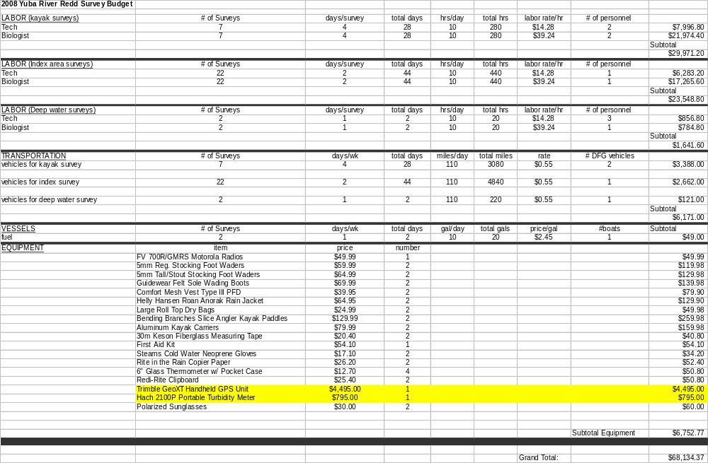

  - Equipment
Redd Surveys
- Kayak | - Waterproof plastic cover
- Trimble Geoexplorer GPS unit, with data dictionary loaded | - Data Box
- Chest Waders or Wading Boots | - Data Forms
- Wetsuit(s)/mask(s) | - Pencils
- Boots | - Digital Camera
- Gloves | - Gaffs
- Survey Protocols and Procedures | - Data Sheets
- Clipboards | - Turbidity Vials
- Brimmed Hat | - Field Notebook
- Dry Cloth (to dry off equipment, etc.) | - Polarized Sunglasses
- Cellular or Satellite Phone | - Measuring Tape
- Contact and Emergency Phone Numbers | - Swift Water Safety Gear
- Food and Water | - First Aid Kit
- UC Davis Key | - Lifejackets/Other Personal  Floatation Devices (inflatable)
- Sunscreen | - Measuring Staff
- Flagging | - Spray Paint
- Stakes | - Decontamination Solution

- Data Management

  - Data Entry and Data Processing

A relational database will be developed using Microsoft Access to manage all of the data collected during the redd surveys. A metadata document will be developed for the database that contains at least: 1) a data dictionary and description of all of the codes, 2) a list of all of the fields in each table, 3) units of measure for each field, 4) description of how the tables are related, 5) description of the purpose of each table, 6) step-by-step explanation of the process to enter data and use any developed queries.

Data on the data sheets will be entered into the relational database and quality assurance and quality control steps will be taken for data entry as described in Section 5.5. Additional quality assurance and quality control (QA/QC) procedures will include a series of queries designed to test if all redds were observed at least once, to look for duplicate records, and to sort individual redd observations by date to ensure that a date of first observation exists in the database. A record of data entry errors will be kept and used to identify and alleviate common problems.

Data stored in the relational database that is needed for GIS analyses will be exported from the database to GIS software.

  - Data Storage and Archival Procedures

All original data sheets will be photocopied, well organized, clearly labeled, and archived. Photo copied datasheets will be used for data entry.

Reports will be prepared annually and archived. Electronic versions of the data sets, as well as hardcopies of reports, will be submitted to the RMT Planning Group.

- Raw Data Electronic Storage Format (Software): Microsoft Access
- Processed Data Electronic Storage Format (Software): Microsoft Excel, Access, ArcMap

Electronic files and print copies of the field data sheets will be located at:

Yuba County Water Agency California Department of Fish and Game
1220 F Street 2545 Zanella Way, Suite F
Marysville, CA 95901-4226 Chico, CA 95928

Data Retrieval Contact: M&E Lead Biologist – Colin Purdy
Telephone Number: (530) 895 - 5522
Email Address: CPurdy@dfg.ca.gov

References

CDFG. 2001. Preliminary Draft Evaluation of Effects of Flow Fluctuations on the Anadromous Fish Populations in the Lower American River. Stream Evaluation Program Technical Report No. 01-2. Prepared for U.S. Bureau of Reclamation.

EA Engineering Science and Technology. 1992. Lower Tuolumne River Spawning Gravel Availability and Superimposition - Appendix 6. Don Pedro Project, Fisheries Study Report FERC Article 39, Project No. 2299.

Hannon, J. and B. Deason. 2005. American River Steelhead (Onchorhynchus Mykiss) Spawning 2001 - 2005. Central Valley Project, American River, California Mid-Pacific Region.

Hayes, J. W. 1987. Competition for Spawning Space Between Brown Trout (Salmo trutta) and Rainbow Trout (S. gairdneri) in a Lake Inlet Tributary, New Zealand.
Canadian Journal of Fisheries and Aquatic Science 44:40-47.

Kucera, P. A., Orme, R. W. (2007). Chinook Salmon (Oncorhynchus tshawytscha)Adult Escapement Monitoring in Lake Creek and Secesh River, Idaho in 2006. Annual Report
January 2006 – December 2006.

McNeil, W. J. 1964. Redd Superimposition and Egg Capacity of Pink Salmon Spawning Beds. Journal of the Fisheries Research Board of Canada 21:1385-1396.

Oregon Department of Fish and Wildlife. 1999. Evaluation of Spawning Ground Surveys for Indexing the Abundance of Adult Winter Steelhead in Oregon Coastal Basins. http://oregonstate.edu/dept/ODFW/spawn/pdf%20files/reports/steel.pdf

USFWS. 2008. Flow-Habitat Relationships for Spring and Fall-run Chinook Salmon and Steelhead/Rainbow Trout Spawning in the Yuba River. Prepared by personnel of the Energy Planning and Instream Flow Branch. Sacramento, California.

Williams, J. G. 2006. Central Valley Salmon: A Perspective on Chinook and Steelhead in the Central Valley of California. San Francisco Estuary & Watershed Science 4, Issue 3, Article 2

Attachment 1

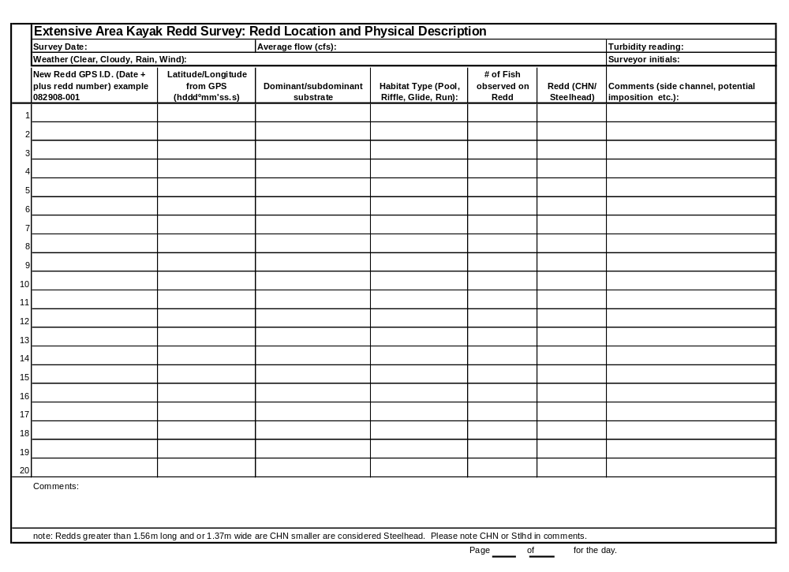

Attachment 2

Front side of the data sheet for the index area redd survey.
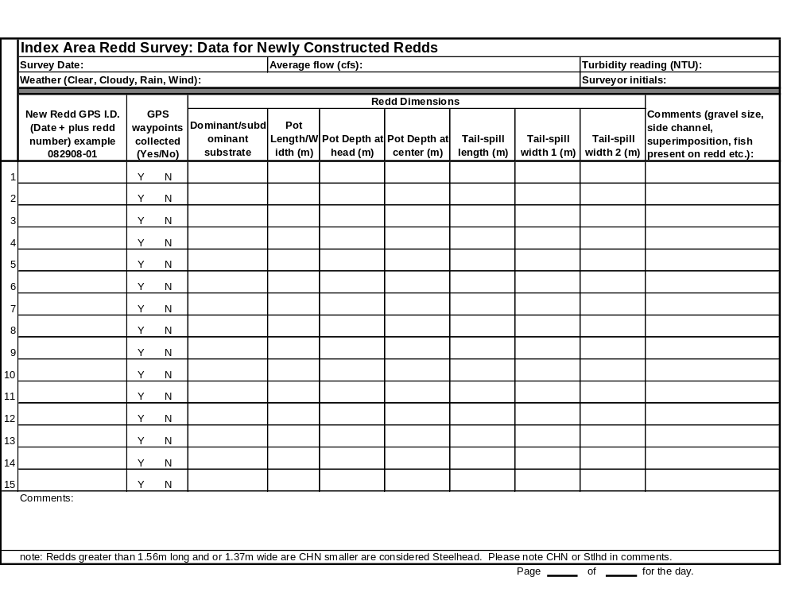

Back side of the data sheet for the index area redd survey.

